P0LITICAL JUGGERNAUTS: A QUANTATIVE ANALYSIS OF THE CANDIDATES IN THE 2019 LOK SABHA

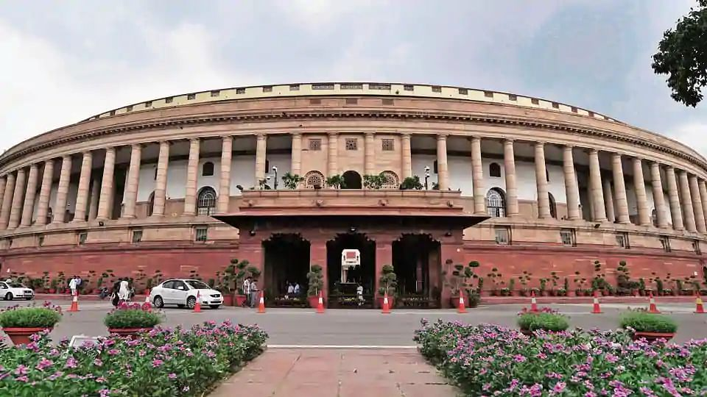

1.INTRODUCTION

OVERVIEW

The Lok Sabha is composed of representatives of people chosen by direct election on the basis of universal adult suffrage.The constitution of india allows for a maximum of 550 members in the house with 530 members representing the states and 20 representing the union territories. The 17th lok sabha was formed by the members elected in the 2019 indain general election. Elections all across india , Were conducted in seven phases from 11 April 2019 to 19 May 2019 by the election commission of india.

PURPOSE

The Bharatiya Janatha party received 37.36% of the vote. The highest vote share by a political party since the 1989 general election and won 303 seats further increasing its substantial majority. In addition the BJP-led national democratic alliance (NDA) won 353 seats.

2.PROBLEM DEFINITION & DESIGN THINKING

* EMPATHY MAP;
* BRAINSTORMING MAP;

EMPATHY MAP:

An empathy map is a collobarate tool teams can use to gain a deeper insight into the people. Much like a user personal an empathy map can represent a group of user such a customer segment. The empathy map was originally created by dale gray and has gained much popularity within the agile community.

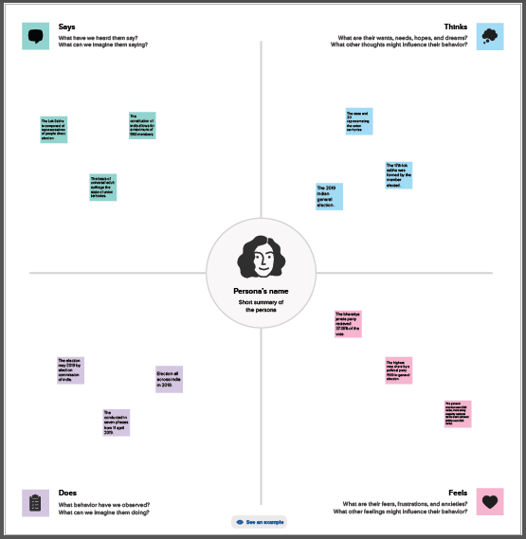

BRAINSTORMING MAP:

Brainstorming is a group problem-solving method that involves the spontaneous contribution of creative ideas and solutions. This technique requires intensive, freewheeling discussion in which every member of the group is encouraged to think aloud and suggest as many ideas as possible based on there diverse knowledge.

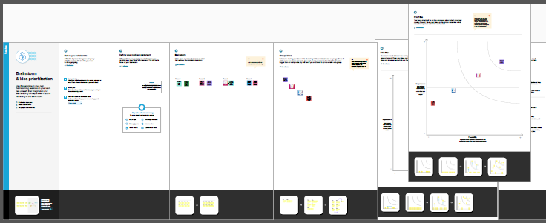

3.RESULT:

* Collect the Dataset.
* Dataset connect with Tableau.

ACOLLECT THE DATASET:

* This dataset is based on the lok sabha 2019 in india. There are a total of of 2263 rows and 19 columns in this dataset. By using this dataset this data analysis project is created.
* Here we use google COLAB to run these codes and analysis the dataset but you can use other platforms also to run the code.
* We have used a total of one dataset for this projects.

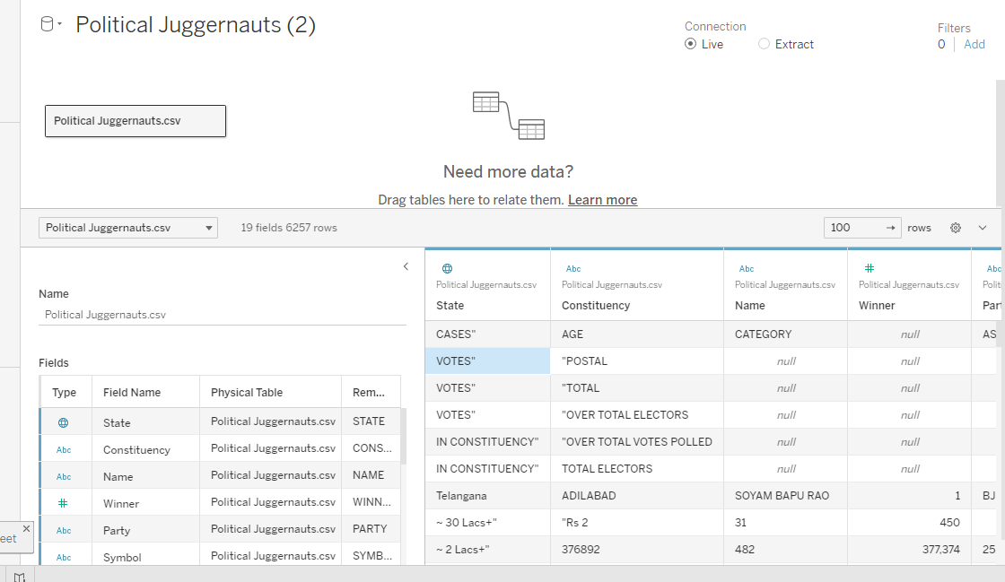

DATA PREPARATION

* The Lok Sabha or House of the people, is the lower house if India’s bicameral parliament with the upper house.
* Member of the lok sabha are elected by an adult universal suffurage.
* The house ,meets in the lok sabha chambers of the New Delhi.

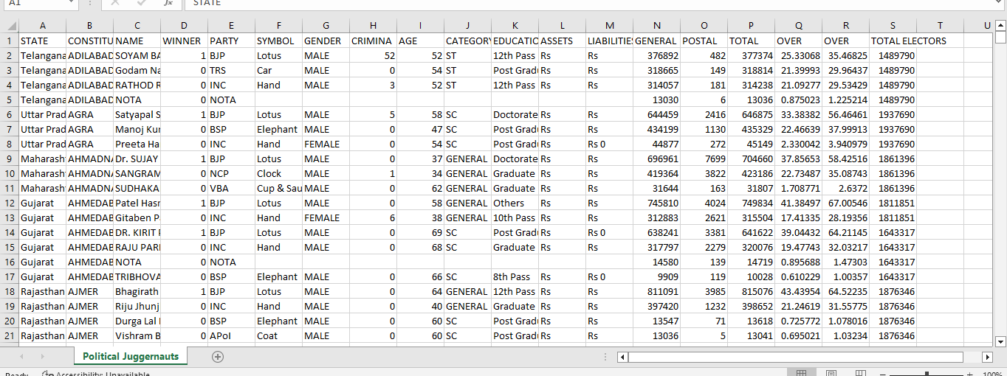

DATASET CONNECT WITH TABLEAU:

* Installed the tableau desktop.
* Insert the dataset in tableau.

DATA VISUALIZATION

* Clear Headings and Keys…
* Obvious Trends…
* Simple Analysis…
* Relevant Comparison…
* Lots of Data /Evidence…
* Summaries of key points…
* Add Design Elements…
* Consolidated Information…

DASHBOARD:

* A Dashboard is a graphical user interface (GUI) that displays information and data in an organize.
* Combine two or more sheets create a dashboard.

DASHBOARD 1 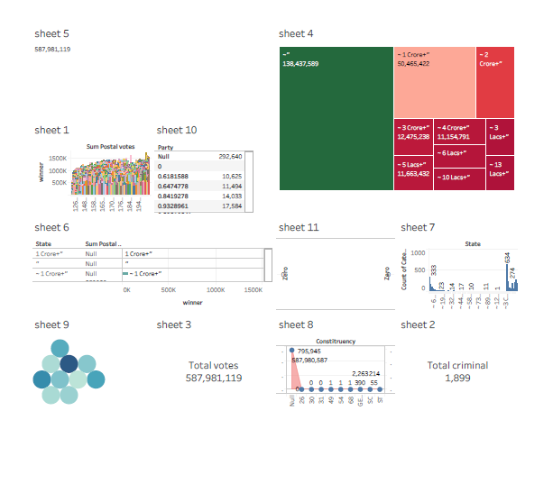

DASHBOARD 2 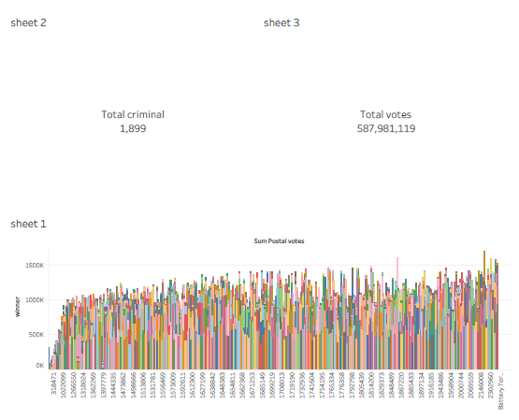

DASHBOARD 3

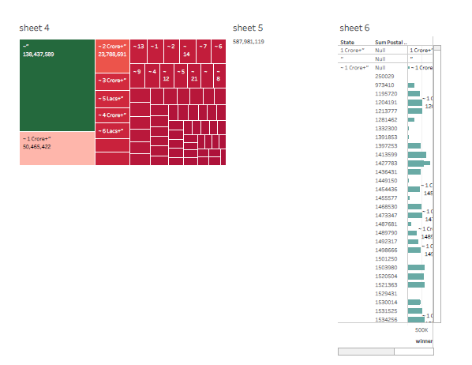

DASHBOARD 5 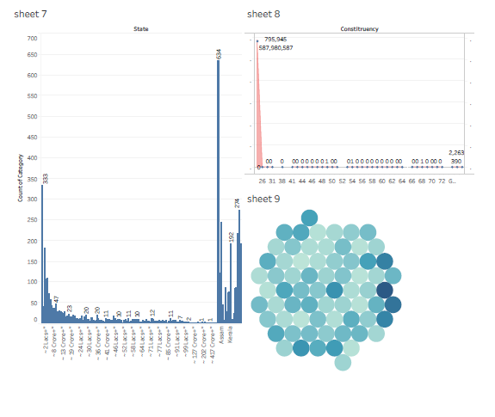

DASHBOARD 5 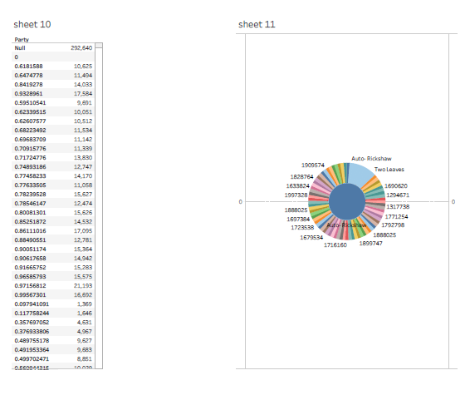

STORY:

* A Data story is a way of presenting data and analysis in a narrative format, with the goal of making the information more engaging and easier to understand.

STORY CREATION:

* Create story point.
* Explore layout options.
* Format a story.
* Resize a captions.
* Fit the sheets are one by one.
* Format a story’s shading, title and text objects.

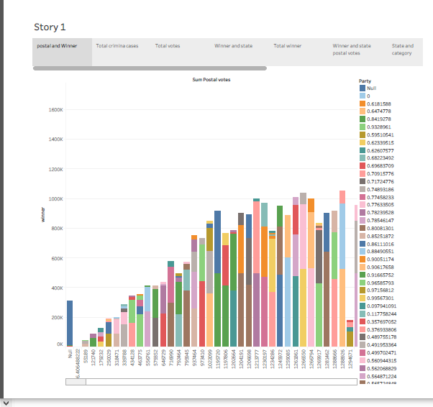

PUBLISHING:

Publishing helps us to track and monitor key performance metrics, to communicate results and progress help a publishers stay informed, make better decisions, and communicate the performance to others.

PUBLISHING DASHBOARD AND REPORTS TO TABLEAU PUBLIC:

STEP:1 Go to dashboard / story, click on share button on the top ribbon.Give the server address of your tableau public account and click on connect.

Server Address: public.tableau.com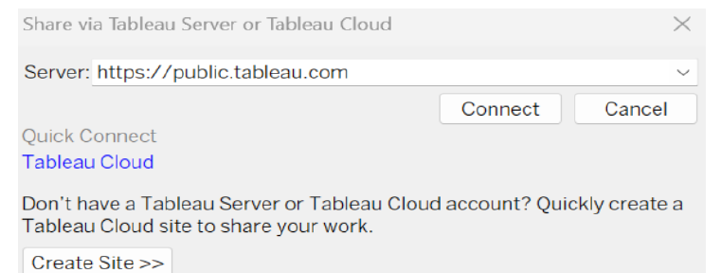

STEP:2 Once you click on connect it will ask you for tableau public user name an password.

Once you login into your tableau publish using the credentials, the particular visualization will be published into tableau public.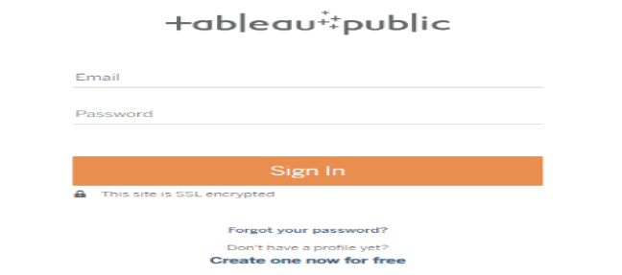

While publishing the visualization to the public, the respective sheet will get publish when you click on share option.

4.ADVANTAGES & DISADVANTAGES:

ADVANTAGES:

* The Lok Sabha has 543 members directly elected by the country’s citizens.
* The responsible for the president’s confidence in choosing the country’s prime minister.
* Lok Sabha members have a tenure of 5 years , after which the assembly and the members dissolve to have a fresh election.

DISADVANTAGES:

* Members of loksabha are directly elected by citizen of country so it represent the voices of common Indian.
* In democracy number matter and clearly loksabha has a edge over rajyasabha in term of numbers.
* Money bill can only be introduced in loksabha and the upper house has to pass it in 15 days.

APPPLICATION:

You use the solutions application to create and manage solution records within a service Desk environment. It is the administrative application and is separate from the search solutions application that customers use to find solutions.

CONCLUSION

A conclusion is the final piece of writing in a research paper, essay, or article that summarizes the entire work. The conclusion paragraph should restate your thesis, summarizes the key supporting ideas you discussed throughout the work, and offer your final impression on the central ideas.

FUTURE SCOPE

Which has in fact just been added but not yet used ,allows the manager to specify certain module sessions as a having a ‘Non-register group.

The can go on to pursue careers in journalism, education, law,communication, government,business,politics etc…

APPENDIX

SOURCE CODE:

A regards non-compliance by state government and other authorities with the inspection issued by the government of india from time to time, the cabinet secretary stated that fresh instruction could be issued or in the alternative, if the committee made certain suggestions, the same could be taken into consideration by the government.

DASHBOARD:1

[https://public.tableau.com/views/DASHBOARD1\_16964827124150/Dashboard1?:language=en-US&publish=yes&:display\_count=n&:origin=viz\_share\_link](https://public.tableau.com/views/DASHBOARD1_16964827124150/Dashboard1?:language=en-US&publish=yes&:display_count=n&:origin=viz_share_link" \t "_blank)

DASHBOARD:2

<https://public.tableau.com/views/DASHBOARD2_16966835346860/Dashboard2?:language=en-US&publish=yes&:display_count=n&:origin=viz_share_link>

DASHBOARD:3

[https://public.tableau.com/views/DASHBOARD3\_16966837885060/Dashboard3?:language=en-US&publish=yes&:display\_count=n&:origin=viz\_share\_link](https://public.tableau.com/views/DASHBOARD3_16966837885060/Dashboard3?:language=en-US&publish=yes&:display_count=n&:origin=viz_share_link" \t "_blank)

DASHBOARD:4

[https://public.tableau.com/views/DASHBOARD4\_16966839594510/Dashboard4?:language=en-US&publish=yes&:display\_count=n&:origin=viz\_share\_link](https://public.tableau.com/views/DASHBOARD4_16966839594510/Dashboard4?:language=en-US&publish=yes&:display_count=n&:origin=viz_share_link" \t "_blank)

DASHBOARD:5

[https://public.tableau.com/views/DASHBOARD5\_16966841233740/Dashboard5?:language=en-US&publish=yes&:display\_count=n&:origin=viz\_share\_link](https://public.tableau.com/views/DASHBOARD5_16966841233740/Dashboard5?:language=en-US&publish=yes&:display_count=n&:origin=viz_share_link" \t "_blank)

|  |  |  |  |  |
| --- | --- | --- | --- | --- |
| |  | | --- | |  | |  |  |  |
| |  | | --- | | STORY: [https://public.tableau.com/shared/DZHNX79X5?:display\_count=n&:origin=viz\_share\_link](https://public.tableau.com/shared/DZHNX79X5?:display_count=n&:origin=viz_share_link" \t "_blank) | | | |
|  | | |  |